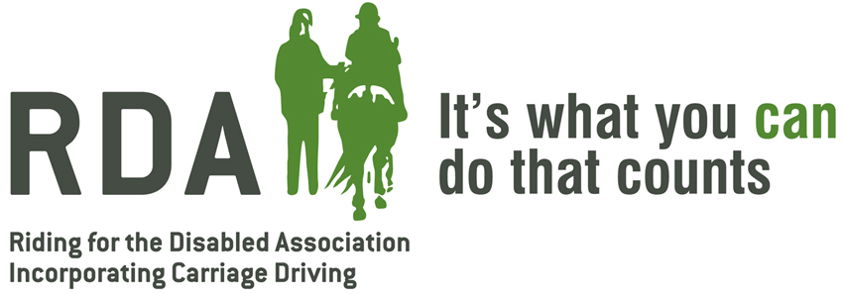

GIFT AID DECLARATION

Details of donor:
Title: Forename(s): Surname: ____________________________

Address: ____________________________________________

____________________________________________________

____________________________________________________

Postcode:____________________________________________

I want Lowlands Farm RDA charity to treat:
•the enclosed donation of £ ___________ as a Gift Aid Donation
•all donations that I make from the date of this declaration until I notify you otherwise as Gift Aid donations
•all donations I have made for the six years prior to this year, (but no earlier than (6/4/2000) and all donations I make from the date of this declaration until I notify you otherwise, as Gift Aid donations.

*Delete as appropriate

You must pay an amount of Income Tax and/or Capital Gains Tax at least equalto the tax that the charity reclaims on your donations in the appropriate taxyear. (Currently 25p for each £1 you give)

Date: ________________ Signed ____________________________

NOTES
1. You can cancel this Declaration at any time by notifying the charity.
2. If in the future your circumstances change and you no longer pay tax on your
income and capital gains equal to the tax that the charity reclaims, you can
cancel your declaration.
3. If you pay tax at the higher rate you can claim further tax relief in your Self
Assessment tax return.
4. If you are unsure whether your donations qualify for Gift Aid tax relief, ask
the charity. Or, refer to help sheet IR65 on the HMRC website.(www.hmrc.gov.uk)
5. Please notify the charity if you change your name or address.

PLEASE RETURN TO:

